**Stray Capacitance**

**1.** **Description** 1

**2.** **Principle of stray capacitance** 1

**3.** **Stray Capacitance Tab** 1

**4.** **Other Tab** 2

## Esteban Malaval, 06/06/2016 12:03

## **Description**

This device represents the stray capacitance of an element.

## **Principle of stray capacitance**

A Stray capacitance device must be placed at each pin of the devices whose stray capacitance will be calculated as shown in figure 1.



**Figure 1. Disposition of the Stray Capacitances**

Some sources give data about the capacitance that exists between the two windings of a transformer. In this case, another instance of this device must be placed here as shown in figure 2.

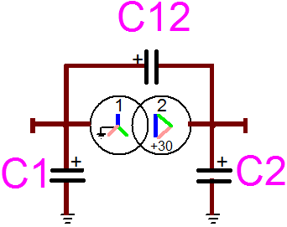

**Figure 2 Disposition of the stray capacitances of a transformer**

## **Stray Capacitance Tab**

**C**: Indicate the value of this stray capacitance

**Choose a capacitance value from Database**: If this checkbox is not checked, any value of capacitance can be written in the case above. If it is checked, the value of stray capacitance will be chosen from a typical value.

**Source:** select the source that Stray Capacitance Data come from.

**Component Type**: select the type of component whose stray capacitance is represented by this device.

Other Tab will appear and depend on the selected type of devices. These tabs will be used for parameter the capacitance with the data of the device.

**Range of values given by the source**: Indicative values of minimum and maximum values of stray capacitance given by this source for this device.

## **Other Tab**

Please refer to the [RLC help](../../Documentation/Help%20Files/devices/rlc/rlc.pdf)